Online Examination System

Number of Roles

- Student
- Super Admin
- Admin

A) Student Role :-

List of Student Modules

1)Log in
2)Student Registration
3)Forgot Password
4)Personal Details
5)Terms and Conditions
6)Examination

- Log in Page This is First Page for Every User By Using this page user can enter into site. Here I am displaying Forgot password and Registration for new Student.

- Student Registration . if the Student is coming for write Exam at first Time He can Register by giving his Personal details. Then He can get Username and Password.
Here Username and Email id should be unique (if Student entered already existing email or Username at that time it will shows Username is already existed try another.

- Forgot Password: If the User forgot the password then he can retrieve by using His Username or Email Id. User name and Password is Displaying at the time. It will apply already registered students only.

- Personal Details After logged in (Before that we are Checking where the User is appearing First time or Second time within the Three Months If the User is appearing Second time Then I am Not allowing in side the log in page . If First time I am allowing to write the Exam) This Personal Details useful for Confirming details and Updating if required. He Can Update E-mail also if mail id is already existed then giving message to Mail id is already (Existed email and with another username) try another.

- Terms and Conditions : Here I am Displaying instructions to the Student While Writing The Exam like Don't go back while Exam running ,Don't press refresh button etc and Confirm to Continue.(Student Need to Agree the Instructions)

- Examination : Here I am giving Questions corresponding Exam Name When Student Selected Exam Name while One Question at a time He can Navigate by Using Next Button he can navigate the all the Questions Here I am displaying Time(In Minutes) Decreasing order. if the time is Completed before press finish I am saving all the Attempted Questions,result(qualified or not qualified),marks . Finally Page is Redirecting to The Log in Page.

B)Super Admin:-

List of Super Admin Modules

- Log in
- Forgot Password
- Home
- Add Admins
- Admin Details
- Questions
- Set Exam Pattern
- Student Exam Paper
- Student Details
- Send mails to Students
- Profile Details.

- Log in Page. This is First Page for Super Admin By Using this page Super Admin can enter into site.

- Forgot Password:If the Super admin forgot the password, then can retrieve by using His User name or Email Id. User name and Password is Sending to Corresponding mail id.

- Home: This is well come Page for Super Admin. Displayed after logged in.

- Add Admins(Only Super Admin):Super admin can add Department admins for Doing some Department wise operations(Creating an account for new Admin).Here He can select which department is belongs to, after registration Username and Password is given to Corresponding admin(Super Admin give Username and password to Admin).

- Admin Details(Only Super Admin):Super admin can Delete Admins and Change Admins Department also and update admin profile details too.

- Questions(All Exams): All the Questions of Corresponding Exam Name he can select . For example if Super admin select C# Exam Name, he can Insert(new Question),Update and Delete. Here Super Admin can see all department Questions.

Add Exam name(Only Super Admin): If Super Admin wants to Add New Exam for Students he can add by giving Exam name.

- Set Exam pattern(All Departments):

At First time Displaying Exam pattern record for particular Exam name whose Questions at least 10. Super Admin Can view All the Exams Pattern Details.
When he select particular Exam Name All Details Shown in Text boxes he can update it. Here we can give Exam Details Like Time Duration for Exam, Pass marks and Number of Questions.(Note : Here If the User enter the 10 Questions then Only he can view the Exam pattern for particular Exam)

Minimum Number of Questions at least: 10
Minimum Time Duration for Writing Exam At least :5(Minutes)
Time Should not more then Double Number of Qustions(i.e if noofquestions 10 then Time Durations not more then 20(2*NumberofQuestions))
Pass marks should Not Zero.

- Student Exam Paper(All the Students): Here admin can see Particular student Attempted Questions Number of Questions has given and Student information. He can search by student name and Department wise Students too.
In Student Paper Details I am showing Questions,User answer Corresponding Options
User Details

- Students Details: List of All the registered Students and complete details, And He can also choose Department wise Students in that He can choose Options(Dropdown) like qualified or not qualified. Or Search by Username.

- Send Mails to Students: Depending on pass marks who got pass marks their Details displayed here, we can send mails to who qualified for the Exam and Admin can view already sent mails to students
Filtering Options like Conducted Exam date or By Department or Who got above particular marks. Filtering options has both sending mails as well as already sent mails.
(Note:Mails can be send Only One time second time)

- Profile: This is common module for Super Admin and Admin they can change or update their details.
Note: Super Admin can do what are the actions performed by the admin

C)Admin(Department Level only):-

List of Admin Modules

- Log in
- Forgot Password
- Home
- Questions
- Set Exam Pattern
- Student Exam Paper.
- Sending Mails to Students
- Profile

- Log in Page. Log in Credentials given by Super admin(username and password)
This is First Page for Admin By Using this page Admin can enter into site.

- Forgot Password:If the Admin forgot the password, then can retrieve by using His User name or Email Id. User name and Password is Sending to Corresponding mail id.

- Home: This is welcome Page for Admin. Displayed after logged in.

- Questions:All the Questions of Corresponding Department if The Admin belongs to C#(Admin) then C# Questions only he can Insert(new),Update and Delete. Here Super Admin can see all department Questions.

- Set Exam pattern: He can set Exam pattern for His Department only. Here we can give Exam Details Like Time Duration for Exam, Pass marks and Number of Questions.(Note : Here If the User enter the minimum 10 Questions then Only he can view the Exam pattern for particular. ).
Minimum Number of Questions at least: 10
Minimum Time Duration for Writing Exam At least :5(Minutes)
Time Should not more then Double Number of Qustions(i.e if no. of questions 10
then Time Durations not more then 20(2*NumberofQuestions))
Pass marks should Not Zero.

- Student Exam Paper: Here admin can see Particular student Attempted Questions Number of Questions has given and Student information. He can search by student name and Department wise Students too(Restrict to Admin department).
In Student Paper Details I am showing Questions,User answer Corresponding Options
User Details

- Students Details: List of registered Students and complete details. He can choose Options like qualified or not qualified or Search by User name.

- Sending Mails Students: Depending on pass marks corresponding Exam name, who got pass marks, displayed their Details here, we can send mails to who qualified for the Exam and Admin can view already sent mails to students.

- Profile: Admin can change or update his details and also change Password(Previous password never same as new password).

User Execution Flow:
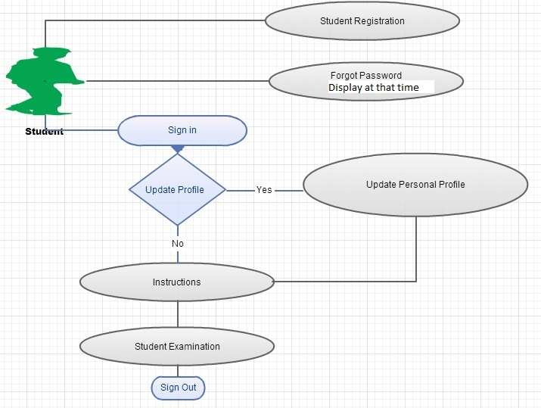

Admin Execution Flow:

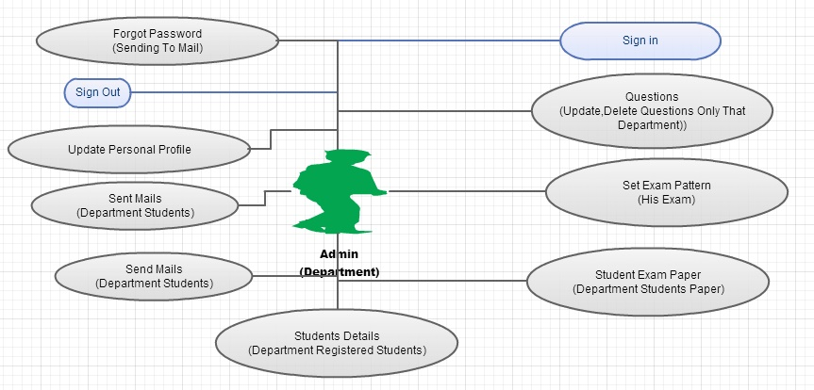

Super Admin Execution flow:
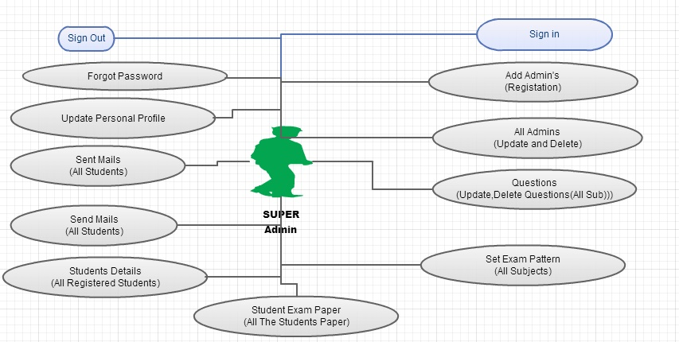

Database :

